
Programme : B. E / B. tech
Course Code : CSA43
Course Name : Internet programming
Name:G.Chakradhar
RegNO:192311439

GIT HUB LINK: https://campus-service-portal-nine.vercel.app/
Problem Statement (Assignment) Max Marks: 100
Field | Content
Assignment Title | Smart Campus Service Management System
Course Outcome(s) – CO | CO1: Develop visually appealing web pages using CSS for layout and style, and create dynamic, interactive functionality with JavaScript.  CO2: Build dynamic web applications using XML, XSLT, and JSP within the MVC paradigm for efficient data handling and presentation.
Bloom’s Taxonomy Level | L3 – Apply | L4 – Analyze | L5 – Evaluate | L6 – Create
SDG Mapping (SDG 1–17) | SDG 9 - Industry, Innovation and Infrastructure, SDG 4 -  Quality Education
Problem Statement
A university currently relies on manual communication such as emails, phone calls, and paper-based records for reporting and resolving campus service issues. This approach makes it difficult to efficiently record complaints, assign requests to the appropriate service personnel, monitor progress, and provide timely status updates to students and faculty.

The university therefore proposes to develop a Smart Campus Service Management System as an integrated web-based application. The system shall enable students and faculty to submit service requests related to laboratory equipment faults, network problems, classroom maintenance, library services, and other technical issues through a web browser. Users should be able to provide relevant details, submit requests, and subsequently track the status of their requests.
The proposed system should demonstrate an integrated client-server web architecture. The client side shall provide an interactive and user-friendly interface using HTML/XHTML, CSS, JavaScript, and DOM. The server side shall process requests using Java Servlets and JSP, following the MVC architecture. XML shall be used for structured data representation, and XSLT shall be used to transform XML data for presentation where appropriate.

Problem Identification (10 Marks)-The university relies on manual communication (emails, phone calls, paper records) for reporting and resolving service issues, which causes inefficiency in recording complaints, assigning requests, monitoring progress, and providing timely updates.
Proposed Solution -Develop a Smart Campus Service Management System (10 Marks), a web-based application that allows students and faculty to submit service requests (lab equipment faults, network problems, classroom maintenance, library services) and track their status online.
System Design & Architecture - Data Representation (20 Marks) -Implement an integrated client-server web architecture. The client side should use HTML/XHTML, CSS, JavaScript, and DOM for interactivity, while the server side should use Java Servlets and JSP following the MVC model. Use XML for structured data representation for transforming XML data into user-friendly formats for presentation and reporting.
Implementation & Testing (10 Marks) -Demonstrate request submission, assignment to service personnel, progress tracking, and timely updates. Validate inputs, handle errors, and ensure smooth user experience.

STG Goals –SDG 9 - Industry, Innovation and Infrastructure, SDG 4 - Quality Education

Requirement Analysis (SDG 9 – Industry, Innovation & Infrastructure) Identify inefficiencies in manual reporting and propose a digital infrastructure for service management.
Client Interface Development (SDG 4 – Quality Education) Build user-friendly web forms and dashboards so students/faculty can easily submit and track requests, improving access to campus services.
Assessment Criterion | CO Mapping | Weightage / Marks
Problem understanding & formulation | CO1 | 10
Application of course/domain knowledge | CO2 | 20
Solution methodology / design / implementation | CO3 | 20
Use of appropriate modern tools / techniques | CO4 | 10
Results, testing & validation | CO4 / CO5 | 15
Analysis, trade-offs & justification | CO5 | 15
Broader considerations / professional responsibility, where applicable | CO5 | 5
Technical documentation & reflection | CO1–CO5 | 5
TOTAL |  | 100

Performance Level | CO Attainment Percentage | Interpretation
Level 3 | ≥ 70% | CO Attained
Level 2 | 60–69% | CO Moderately Attained
Level 1 | 50–59% | CO Minimally Attained
Level 0 | < 50% | CO Not Attained

Code of Conduct
I G.CHAKRADHAR(192311439) certify that this submission is my original work and that I have adhered to the guidelines specified for this assessment. I understand that any violation of academic-integrity rules will result in disciplinary action.

Signature of the Student: 
_____________________  Faculty In-charge  Name:  Date: | _____________________  Course Coordinator  Name:  Date: | _____________________  Head of Department  Name:  Date:

SMART CAMPUS SERVICE MANAGEMENT SYSTEM

1. Problem Statement
The university currently uses emails, phone calls, and paper records to report and manage campus service issues. This makes it difficult to record complaints, assign them to the correct personnel, track progress, and provide updates to students and faculty.
The Smart Campus Service Management System is proposed as a web-based solution. It allows students and faculty to submit service requests for laboratory equipment, network problems, classroom maintenance, library services, and other technical issues. Users can also track the status of their requests online.
The system uses HTML/XHTML, CSS, JavaScript, DOM, Java Servlets, JSP, MVC, XML, and XSLT as required by the assignment.

2. Objectives
- Provide an online platform for submitting service requests.
- Reduce manual communication and paper records.
- Assign requests to appropriate service personnel.
- Allow users to track request progress.
- Provide timely status updates.
- Develop a user-friendly and interactive web application.
- Demonstrate Internet Programming concepts.

3. Problem Identification
The existing manual system has the following problems:
- Complaints are difficult to organize.
- Request assignment may be delayed.
- Tracking the progress of complaints is difficult.
- Users may not receive timely updates.
- Paper records are difficult to maintain.
The proposed system solves these problems by providing a centralized digital service-request platform.

4. Proposed Solution
The Smart Campus Service Management System provides different functions for users and service personnel.
Student / Faculty
- Login
- Submit service request
- View submitted requests
- Track request status
- View updates and remarks
Service Personnel
- Login
- View assigned requests
- Update request status
- Add progress remarks
- Mark requests as resolved
Request Flow
Submit → Assign → In Progress → Resolved → Closed
This directly demonstrates the required request submission, assignment, progress tracking, and status updates.

5. System Design and Architecture
The system follows a client-server architecture and MVC model.
User
↓
Web Browser
↓
HTML/XHTML + CSS + JavaScript + DOM
↓
JSP
↓
Java Servlet
↓
MVC
↓
Model / Data
↓
XML
↓
XSLT
↓
User-Friendly Output
Model
Contains application data such as users, service requests, service personnel, and request status.
View
JSP pages are used to display information and provide forms and dashboards.
Controller
Java Servlets process user requests and control the application flow.
HTML/XHTML, CSS, JavaScript, DOM, Java Servlets, JSP, MVC, XML, and XSLT are used as required in the assignment.

6. Main Web Pages
Web Page 1 – Login Page
The login page allows students, faculty, and authorized staff to enter their credentials and access the system.
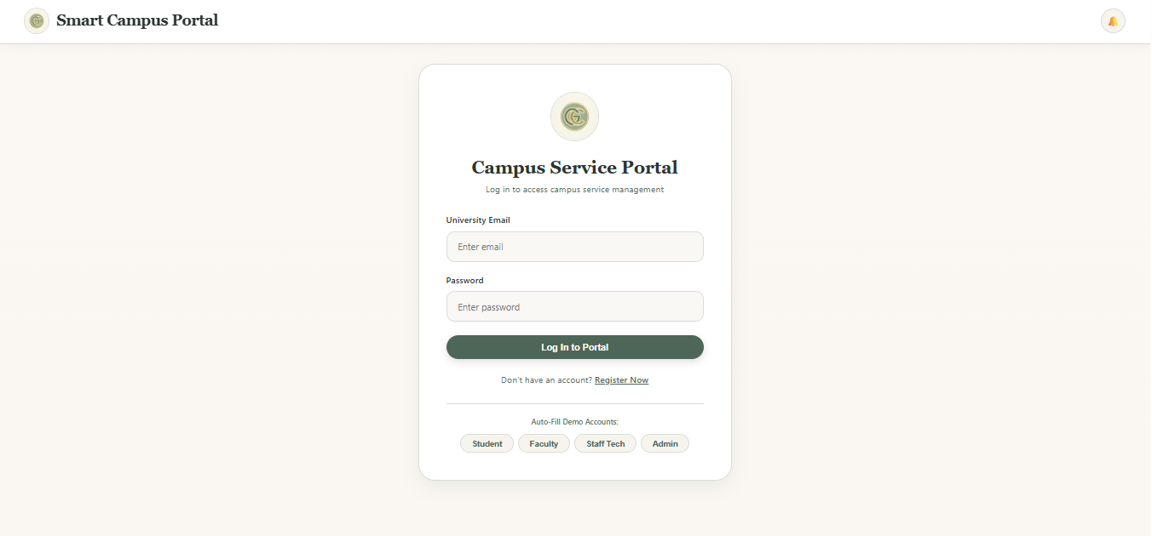
Web Page 2 – User Dashboard
The dashboard provides quick access to service requests and request-tracking functions.
Main options:
- Create Request
- My Requests
- Track Request
- Logout
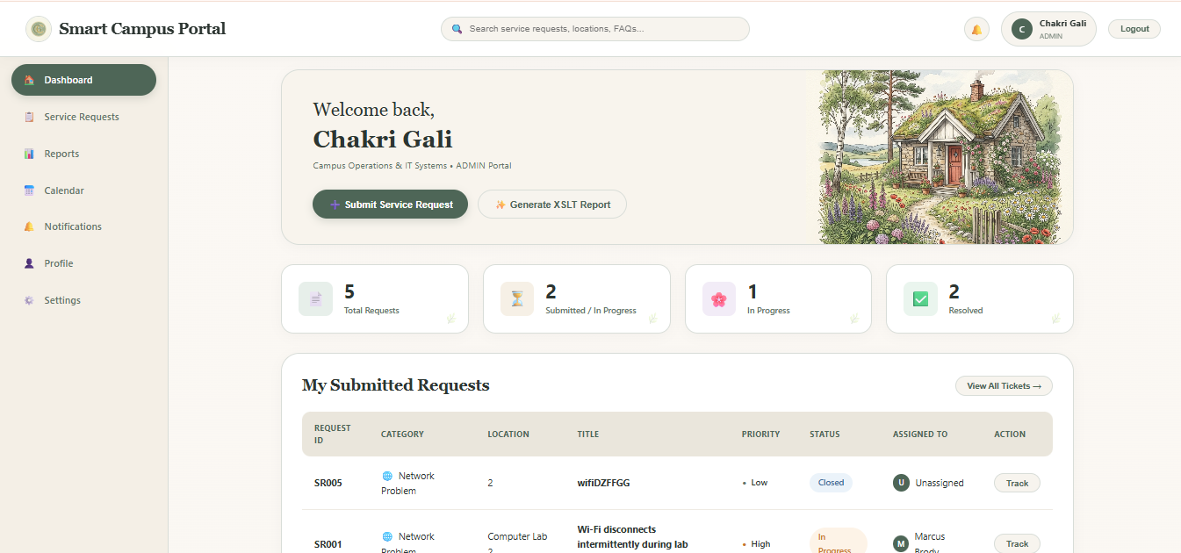

Web Page 3 – Submit Service Request
The request form allows users to report a campus service problem.
Example fields:
- Category
- Location
- Request Title
- Description
- Priority
- Submit Button
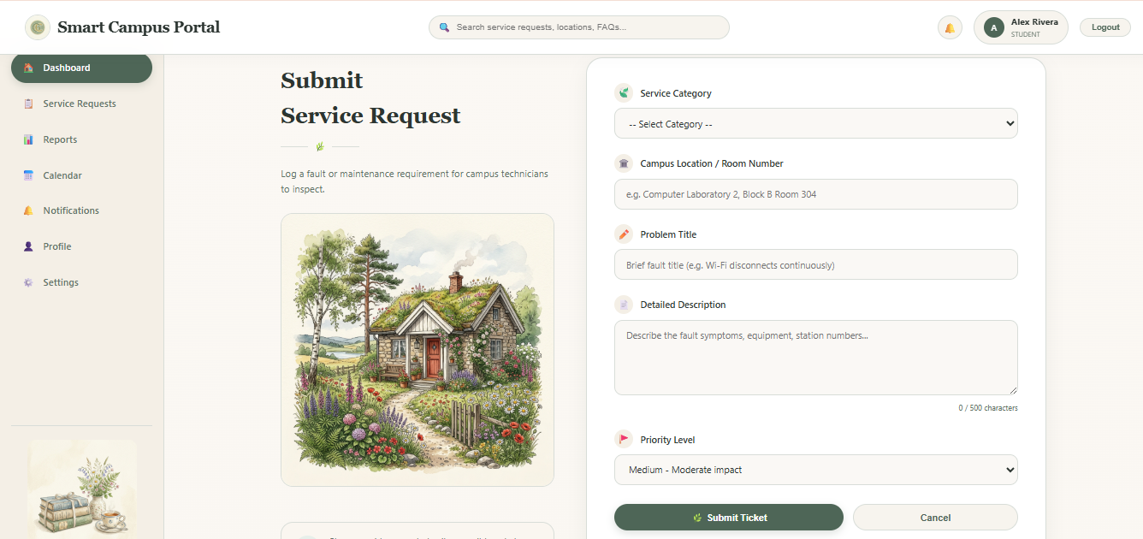
Web Page 4 – My Requests
This page displays the service requests submitted by the logged-in user.
Example information:
Request ID | Category | Location | Status
SR001 | Network | Lab 2 | In Progress
SR002 | Classroom | Room 101 | Resolved

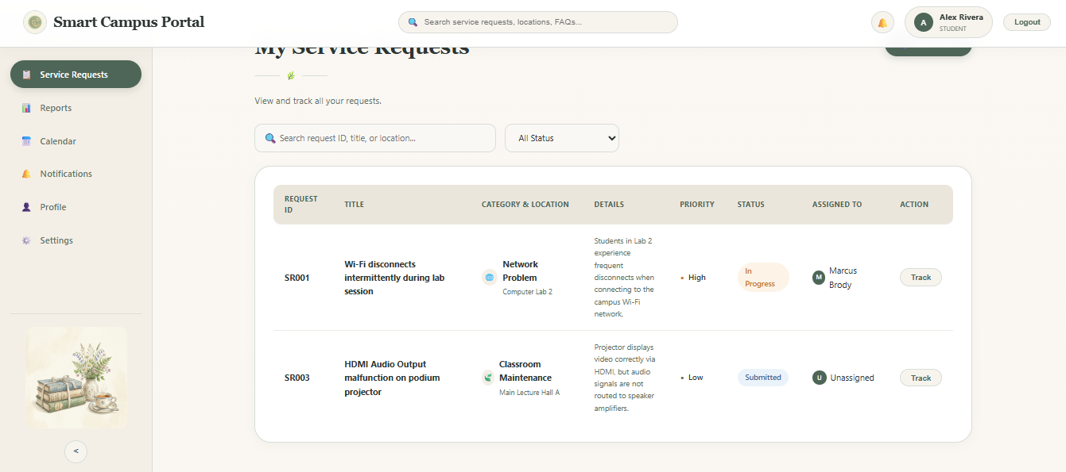

Web Page 5 – Request Details / Tracking
This page displays complete information about a selected request.
Example:
Request ID: SR001
Category: Network Problem
Location: Computer Lab 2
Priority: High
Status: In Progress
Assigned To: Network Technician
Remarks: Network connection is being checked.
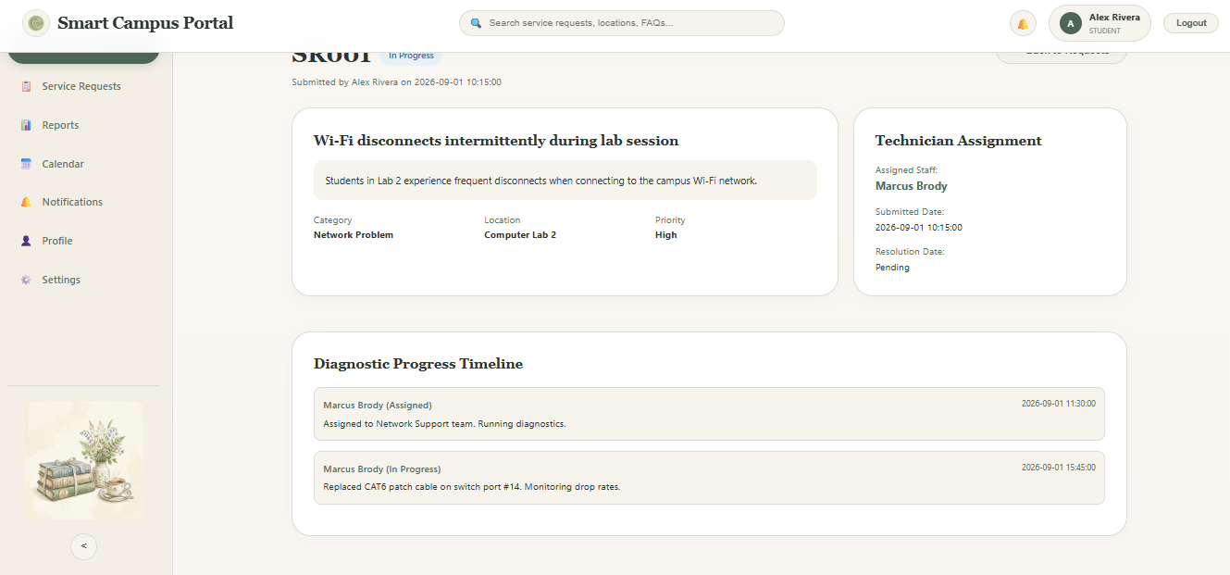

Web Page 6 – Service Personnel Dashboard
Service personnel can view requests assigned to them and manage their progress.
Main functions:
- View requests
- Update status
- Add remarks
- Resolve request

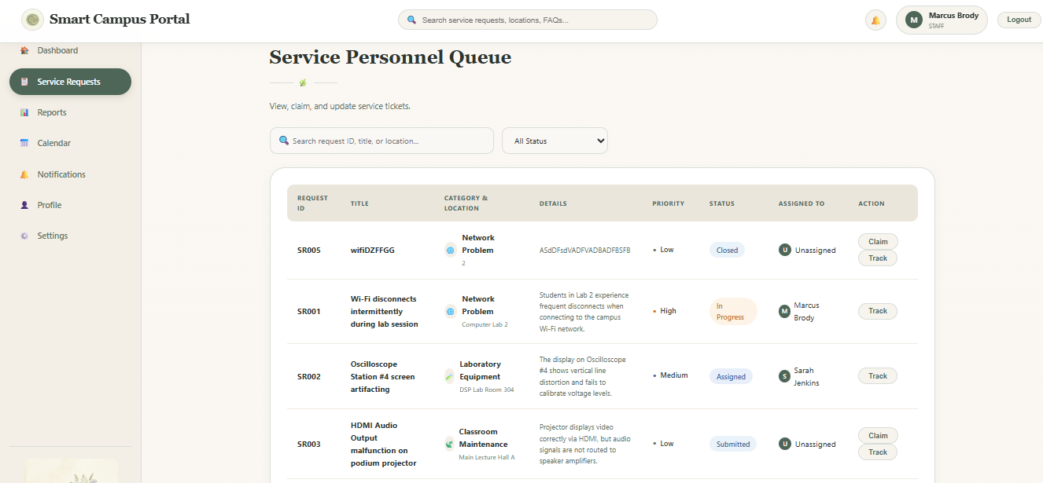

Web Page 7 – Request Status Update
Service personnel can change the request status and enter progress remarks.
Example:
Status: In Progress
Remarks: Technician is checking the network connection.

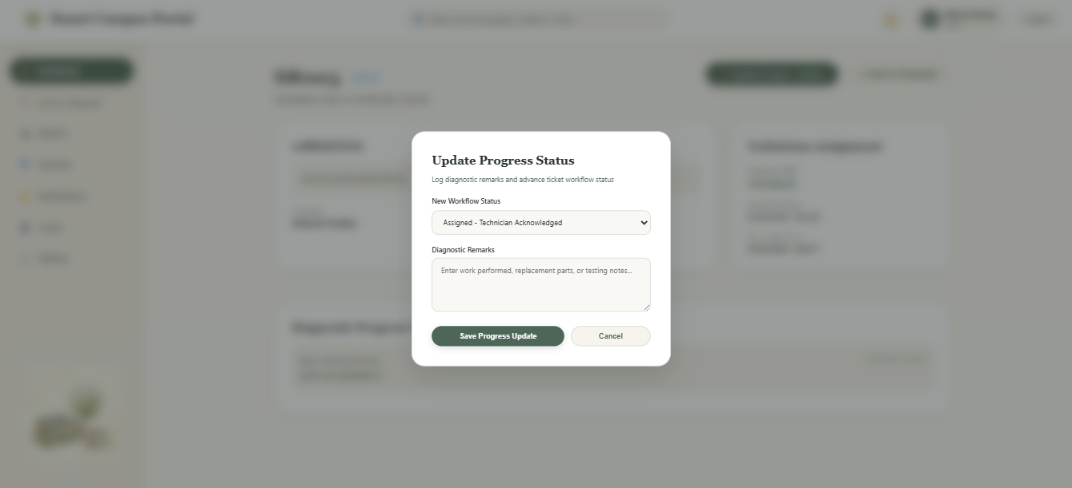

Web Page 8 – XML/XSLT Output
XML is used to represent service-request data in a structured form. XSLT transforms the XML data into a user-friendly display.
Example XML:
<request>
<requestId>SR001</requestId>
<category>Network Problem</category>
<location>Computer Lab 2</location>
<status>In Progress</status>
</request>
Image: XML/XSLT Output
[INSERT XML/XSLT OUTPUT SCREENSHOT HERE]

7. Technologies Used
Technology | Purpose
HTML/XHTML | Webpage structure
CSS | Layout and design
JavaScript | Interactivity and validation
DOM | Dynamic webpage manipulation
Java Servlets | Server-side request processing
JSP | Dynamic webpage presentation
MVC | Application architecture
XML | Structured data representation
XSLT | XML transformation

8. Implementation
The system implements the complete service-request process.
Request Submission
A user enters the problem details and submits the request. JavaScript validates the input and the Servlet processes the request.
Request Assignment
The submitted request is assigned to the appropriate service personnel.
Progress Update
Service personnel update the request status and add remarks.
Request Tracking
The user can view the latest status and progress through the dashboard.

9. Input Validation and Error Handling
The system validates important user inputs.
Examples:
- Required fields cannot be empty.
- Email format is checked.
- Request details must be provided.
- Invalid login details generate an error message.
- Invalid or unavailable requests are handled properly.
JavaScript and DOM can provide client-side validation, while Java Servlets perform server-side validation.

10. Testing and Validation
The following test cases are used to verify the system.
Test Case | Test | Expected Result | Status
TC01 | Valid login | Dashboard displayed | Pass
TC02 | Invalid login | Error message displayed | Pass
TC03 | Empty request | Validation message displayed | Pass
TC04 | Valid request | Request submitted | Pass
TC05 | Assign request | Personnel assigned | Pass
TC06 | Update status | New status displayed | Pass
TC07 | Track request | Current progress displayed | Pass
TC08 | XML processing | XML data displayed | Pass
TC09 | XSLT transformation | Formatted output displayed | Pass
Image: Testing / Output
[INSERT TESTING SCREENSHOT HERE]

11. Results
The developed system provides a centralized method for managing campus service requests.
The main results are:
- Users can submit service requests online.
- Requests can be assigned to service personnel.
- Personnel can update request progress.
- Users can track request status.
- Input validation and error handling are provided.
- XML and XSLT are demonstrated.
- The application provides an interactive web interface.

12. Analysis, Trade-offs and Justification
MVC
MVC separates the application into Model, View, and Controller, making the system easier to manage and maintain.
Servlets and JSP
Servlets handle server-side processing, while JSP provides dynamic webpage presentation.
JavaScript and DOM
JavaScript and DOM provide client-side interaction and validation.
XML and XSLT
XML provides structured data representation, while XSLT converts XML data into a user-friendly format.
Trade-off
Using multiple technologies increases the complexity of development, but it is necessary to demonstrate the Internet Programming concepts required by the assignment.

13. SDG Mapping
SDG 9 – Industry, Innovation and Infrastructure
The project supports SDG 9 by replacing manual service reporting with digital infrastructure. It provides a centralized system for recording, assigning, monitoring, and resolving campus service requests.
SDG 4 – Quality Education
The project supports SDG 4 by providing students and faculty with easy-to-use web forms and dashboards for accessing and tracking campus services.

14. Professional Responsibility
The system should protect user information and provide access only to authorized users. Input validation should be used to prevent incorrect data, and service-request information should be handled securely.
The interface should also be simple and accessible so that students, faculty, and service personnel can use it easily.

15. Tools Used
The project can be developed and tested using:
- Java JDK
- Apache Tomcat
- IDE such as Eclipse, IntelliJ IDEA, or NetBeans
- Web browser
- HTML/CSS/JavaScript
- XML/XSLT
These tools support the technologies required for the project.

16. Reflection
This project provides practical knowledge of developing a client-server web application. It demonstrates how frontend technologies can work together with Java Servlets and JSP using MVC.
The project also provides experience in JavaScript and DOM manipulation, XML and XSLT transformation, input validation, error handling, testing, and web interface development.

17. Conclusion
The Smart Campus Service Management System provides a digital solution for managing university service issues. It allows students and faculty to submit requests, enables service personnel to manage and update requests, and provides users with request tracking.
The project demonstrates the required Internet Programming technologies and provides a practical solution to the problems of manual campus service management. It also supports SDG 9 – Industry, Innovation and Infrastructure and SDG 4 – Quality Education.

